A000-Am,S-Peru-Nazca-Vessel-Female Anthropomorph-Polychrome Ceramic-400 CE

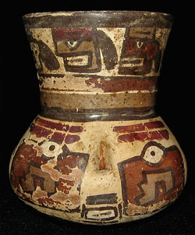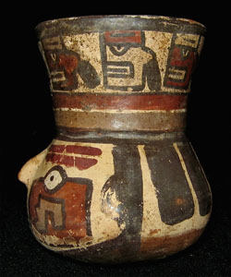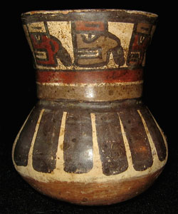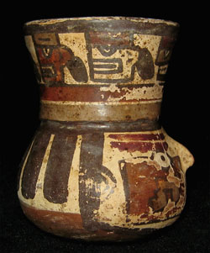

A000-Am,S-Peru-Nazca-Vessel-Female Anthropomorph-Polychrome Ceramic-400 CE

Case No.: 10

**Accession No.**

**Formal Label:** Am,S-Peru-Nazca-Vessel-Female Anthropomorph-Polychrome Ceramic-400 CE

**Display Description:**

Fine polychrome Nazca portrait vessel, depicting a Nazca woman with bulging eyes,  small protruding nose, facial paint on both cheeks and around her eyes, flanked at top by a headband with trophy heads.

**LC Classification:**

**Date or Time Horizon: 400 CE**

**Geographical Area:** South Coast - Peru

**Map:**

**GPS coordinates:**

**Cultural Affiliation:**

**Media:**

**Dimensions:** 3.15" (8 cm) Height

**Weight:**

**Condition: Original.** Nice  intact condition, with minor paint loss.

**Provenance:** Private Collection

**Discussion:**

**References:**

|  | |  | |
| --- | --- | --- | --- |
| Shipping details | |  | |
| **Ralph J Coffman Jr**  149 Atlantic Ave  Swampscott MA 01907-2427  United States | |  | |
| Seller: | [**Member id** precolumbian_antiquities](http://myworld.ebay.com/precolumbian_antiquities) ( [**Feedback Score Of** 463](http://feedback.ebay.com/ws/eBayISAPI.dll?ViewFeedback&userid=precolumbian_antiquities)) | | [Contact seller](http://contact.ebay.com/ws/eBayISAPI.dll?ShowCoreAskSellerQuestion&frm=3998&iid=0&redirect=0&requested=precolumbian_antiquities) |

|  |  |  |  |  |
| --- | --- | --- | --- | --- |
| **Order # 123217384014**  Paid on Oct-22-12 via PayPal | | | | |
|  |  | |  | | --- | |  | | |  |  | | --- | --- | | [Contact seller](http://contact.ebay.com/ws/eBayISAPI.dll?ShowCoreAskSellerQuestion&frm=3998&iid=200833120128&redirect=0&requested=precolumbian_antiquities) |  | | |  |  |

|  |  |  |  |  |  |  |  |
| --- | --- | --- | --- | --- | --- | --- | --- |
| [**Item Title:**PRE-COLUMBIAN NAZCA POLYCHROME PORTRAIT HEAD MINIATURE VESSEL**- opens in a new window or tab**](http://cgi.ebay.com/ws/eBayISAPI.dll?ViewItem&item=200833120128)  **Item Id:**200833120128 - Price: US $195.00  Quantity:1  Having a problem with this purchase? [We can help](javascript:;) | |  | | --- | |  | | |  |  | | --- | --- | | [Leave feedback](http://feedback.ebay.com/ws/eBayISAPI.dll?LeaveFeedbackShow&useridfrom=802-867&useridto=precolumbian_antiquities&item=200833120128&transactid=0) |  | | | Standard Shipping: **US $45.00**  Estimated delivery: November 14 - December 3 | US $195.00 |